Year 10
OLNA class

Quiz 6

2021

Scales and Timetables


Name: ______________________ Class: ______ Time: 20 minutes (strict) Total Mark:____/10

Resources: No calculator allowed

Question 1 3 marks

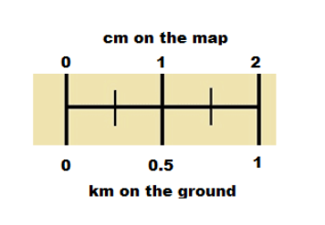
Use the above scale to answer the following questions.

a) If you measured 8cm on the map, how many kilometres (km) would it represent on the ground?

b) If you measured 3cm on the map, how many kilometres (km) would it represent on the ground?

c) If you measured 5.5km on the ground, how many centimetres (cm) would it represent on the map?

Question 2 1 mark

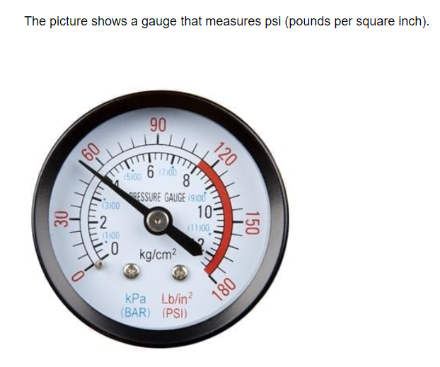
What psi does the dial show? (using the outer numbers)
A) 50 psi B) 54 psi C) 52.5 psi D) 56 psi

Question 3 3 marks
Here is a train timetable from Mandurah to Kwinana.

Mandurah | 07:11 | 07:20 | 07:27 | 07:35 | 07:43 | 07:55
Warnbro | – | 07:28 | 07:33 | 07:43 | 07:49 | 08:03
Rockingham | – | – | 07:38 | – | 07:54 | –
Wellard | 07:25 | – | 07:41 | – | 07:57 | –
Kwinana | 07:32 | 07:41 | 07:48 | 07:56 | 08:05 | 08:16

- How long does it take to get from Mandurah to Kwinana? (answer in minutes)

- An event is on in Kwinana at 08:15. If you were starting your journey in Warnbro and want to be 10 minutes early for the event, what time should you leave Warnbro?

- How many of the six different train times shown stop in Wellard?

Question 4 1 mark
The scale on a map shows 1 cm : 2500 m
How much would 5 cm on the map represent in real life?

A) 25 000 cm B) 12 500 km C) 125 000 m D) 12.5 km

Question 5 1 mark
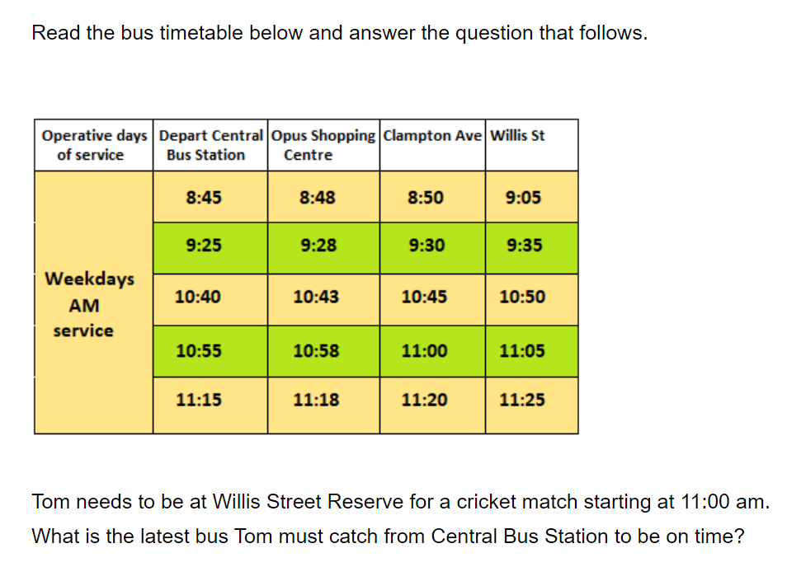

Question 6 1 mark

A) 39.2 kg

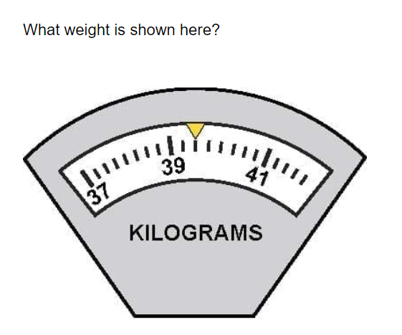
B) 39.25 kg

C) 39.4 kg

D) 39.5 kg

